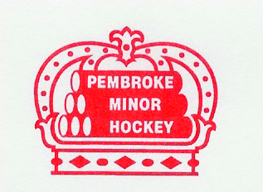
PEMBROKE MINOR HOCKEY ASSOCIATION
P.O. Box 725
PEMBROKE, ON K8A 6X9
Website: pembrokeminorhockey.com
Contact: registrar@pembrokeminorhockey.com

PLAYER REGISTRATION FORM
Division: Click or tap here to enter text. | Association played for last season: Click or tap here to enter text.
Player Name: Click or tap here to enter text.
Date Of Birth: Click or tap to enter a date. | Hockey Canada ID (if known): Click or tap here to enter text.
Player Address: Click or tap here to enter text. |  | # Years at this address:
Parent/Guardian Name(s): Click or tap here to enter text.
Primary Phone: Click or tap here to enter text. | Primary Email: Click or tap here to enter text.
Secondary Phone (if applicable): Click or tap here to enter text. | Secondary Email (if applicable): Click or tap here to enter text.
Emergency Contact Info: Click or tap here to enter text.
Relationship to Player: Click or tap here to enter text.
I/We declare that the above-named player resides at the address noted above. Fees will not be refunded if it is determined that false information has been provided.
Parent/Guardian Name (print) | Parent/Guardian Signature: | Date: Click or tap to enter a date.

FOR OFFICE USE ONLY:
Proof of Age | Uploaded to HCR | Verified By | Date | Fees
Proof of Residency |  |  |  | Payment type

